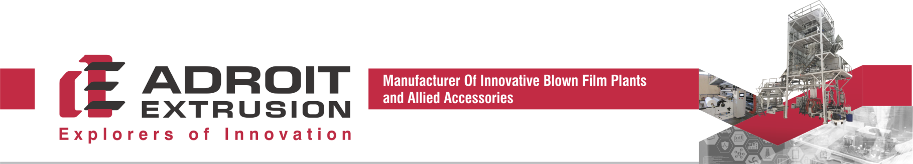

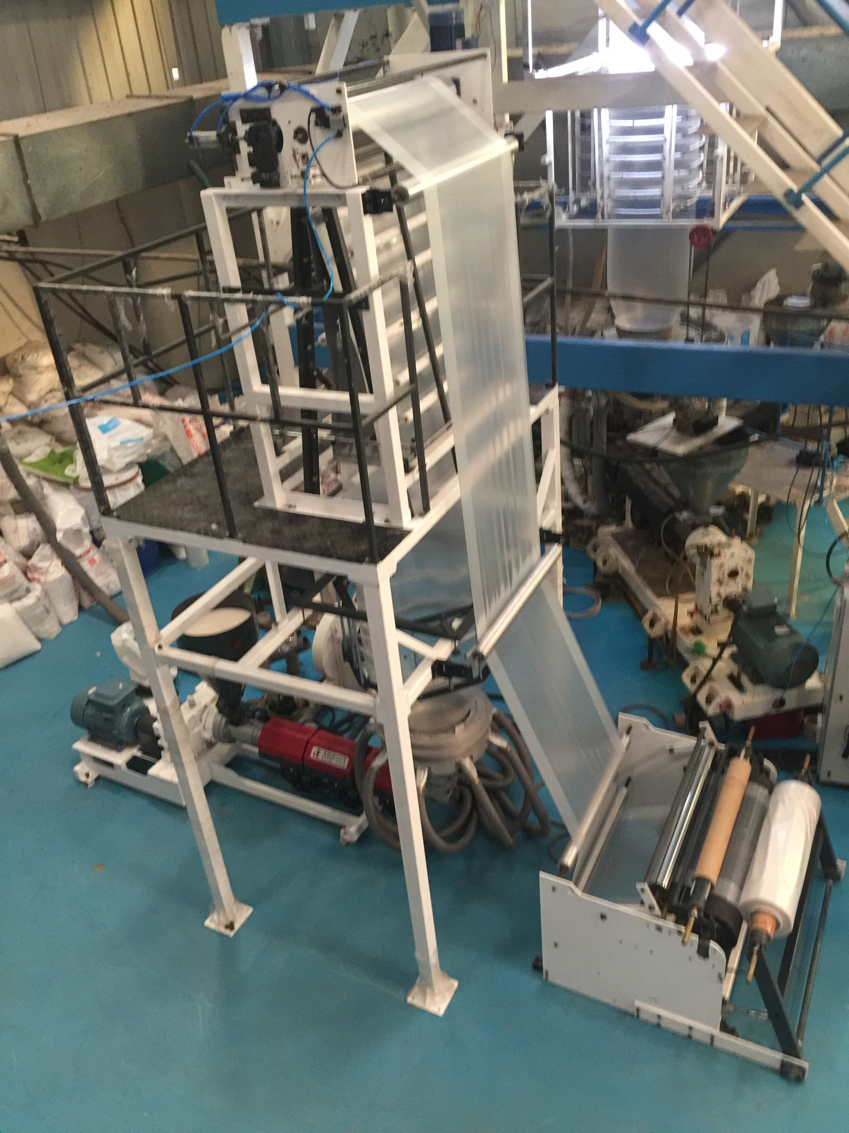

PROPOSAL OF
AE Duoflex ABA CO EXTRUSION BLOWN FILM LINE 500_35*35
FOR
M/s.

____________________________________________________________________________________________________________
Unit 1: Survey 822, Village Bhumapura, Ahmedabad – Mahemdavad Road, Dist. Kheda, Gujarat – 387130, India.
Unit 2: 75/A, Akshar Industrial Park, B/H Amba Estate, Nr. Hathijan Circle, Vatva GIDC Phase-4, Ahmedabad – 382445, India.
Mobile: +919925143048 / +918758665507 Email: info@adroitextrusion.com Website: www.adroitextrusion.com


Ref. No. AEP/DOM/500/001
Date: 06/04/2026

(ADROIT EXTRUSION SCOPE OF SUPPLY)
ITEM # | ITEM DESCRIPTION
1 | Two Nos. Extruders of 35/35 mm screw diameter and L/D ratio of 28:1, Screw & barrel, Ceramic Heater, 7.5 HP AC Motor & AC variable frequency Drive. Two Candle type Manual Screen Changers for 35/35 mm Extruders.
2 | Complete extrusion controls on main panel with Cold start protection.
3 | One Chrome plated Three Layer ABA Spiral Mandrel Die and lip diameter of 75 mm, complete with die adapters and carriage.
4 | Air Ring Package consisting of highly efficient air ring, distributor manifold, High Pressure 2 HP Blower.
5 | One Irish Ring to support the bubble.
6 | Collapsing frame with Segmented wooden slates, side guides, Main Nip with 1 HP AC Drive.
7 | Aluminum Idler rollers as per layout drawing.
8 | One Surface Winders of 450 mm film width. Manual roll change over mechanism, 02 nos.- 3” Mechanical shaft, bow roller, 0.5 HP Torque Motor and Drive.
9
10
11

BASIC PRICE EX-WORKS, UNPACKED ………………. INR 15,85,000.00

(RUPEES FIFTEEN LACS EIGHTY FIVE THOUSAND ONLY)

FINAL PRICE AFTER DISCOUNT ………………. INR 13,75,000.00

____________________________________________________________________________________________________________
Unit 1: Survey 822, Village Bhumapura, Ahmedabad – Mahemdavad Road, Dist. Kheda, Gujarat – 387130, India.
Unit 2: 75/A, Akshar Industrial Park, B/H Amba Estate, Nr. Hathijan Circle, Vatva GIDC Phase-4, Ahmedabad – 382445, India.
Mobile: +919925143048 / +918758665507 Email: info@adroitextrusion.com Website: www.adroitextrusion.com


Product to be made : High Quality Two Layer Film

Max Output * on 75 mm die : 40 – 50 KG / HR
HM HDPE

Raw Materials : HMHDPE

Thickness Range : 15 – 70 micron

Lay flat Width : 450 MM maximum process able width.

Provided that the temperature of air at the air ring will not be more than 10 – 12° C and 2.5 BUR+
Widths only. Ambient temperature and relative humidity within normal range.

NOTES:
- The Output indicated above are based on ambient Condition around 35 deg. C, and relative humidity around 40% range. Temp. at Air ring around 10-12 deg. C.
- Film output, Gauge Variation and Film Quality are dependent on polymer grades, Layflat width, Thickness, Nip height, Die Size and other processing and operating parameters, etc.
- Adequate quantity of PPA to be added to remove melt fracture in the film.
- Gels – Defective resins, dirty screws or processing conditions can cause gels.
- Gloss and Haze – Can be affected by resin, temperature profiles.

____________________________________________________________________________________________________________
Unit 1: Survey 822, Village Bhumapura, Ahmedabad – Mahemdavad Road, Dist. Kheda, Gujarat – 387130, India.
Unit 2: 75/A, Akshar Industrial Park, B/H Amba Estate, Nr. Hathijan Circle, Vatva GIDC Phase-4, Ahmedabad – 382445, India.
Mobile: +919925143048 / +918758665507 Email: info@adroitextrusion.com Website: www.adroitextrusion.com


Screw Diameter : 35 mm single screw extruder mounted on a sturdy frame.
L/D ratio : 28:1
Screw Speed : 95 RPM
Barrel : Water cooled grooved feed section
Material : Nitro Alloy.
Heating System : Ceramic Band type Heaters (Hitco or equivalent)
No. of Zones : 02 Nos. on barrel
Hopper : MS fabricated with glass window for visual inspection.
Magnetic grill provided.
Main Drive : 7.5 HP AC motor (ABB) with frequency variable drive.
Transmission System : Motor directly coupled / Belt with helical gearbox.
Gearbox : Premium or equivalent make.
Screen changer : Candle type

Material of Construction : Hardened high strength alloy steel.
Surface Treatment : Chrome plated & highly polished melt paths.
Die Size : Diameter as per width and lip gap.
Die setting : Die adjusting bolts will be provided.
Heating Zones : 02 Nos.
Heating System : Ceramic band heaters (Hitco or equivalent)

Construcion : Aluminum body aerodynamic type air cooling ring for cooling.
The airing had circular casing with many entry ports 4 efficient cooling.
Blower : 2 HP with inlet air filter.

Type : Irish Ring to Support the bubble.

Main Nip rollers : 02 Nos. mounted in bearings. One chrome plated roller
and one rubber roller movable pneumatically. Knurling Provided
Nip roller width : 500 mm
Nip roller drive : 1 HP AC motor with variable frequency drive.
Collapsing Frames : PBT rollers / Wooden Slates.
Idler rollers : Adequate quantity as per layout.
____________________________________________________________________________________________________________
Unit 1: Survey 822, Village Bhumapura, Ahmedabad – Mahemdavad Road, Dist. Kheda, Gujarat – 387130, India.
Unit 2: 75/A, Akshar Industrial Park, B/H Amba Estate, Nr. Hathijan Circle, Vatva GIDC Phase-4, Ahmedabad – 382445, India.
Mobile: +919925143048 / +918758665507 Email: info@adroitextrusion.com Website: www.adroitextrusion.com


Surface Winder : Maximum web width of 450 mm with Manual Changeover.
Roll diameter : 400 mm diameter or 100 kg weight in single up Which ever reaches first.
Bow roller prior to drum roller for wrinkle free winding.
Surface winder drive : 0.5 HP AC motor with variable frequency drive.
Tension control : Through Torque mode.

Panels : Powder coated panels with exhaust fans.
Synchronisation : For Nips & winder drives.
Switch Gear : Schneider or equivalent make.
Temp. controllers : Fuji or equivalent make with +/- 1 deg. accuracy.
Drives : Delta or equivalent variable frequency drives.
Total connected Load : 40 KW Approx.
Power Supply : 415 V, 50 Hz, with N
Voltage Fluctuation : + /- 5%

____________________________________________________________________________________________________________
Unit 1: Survey 822, Village Bhumapura, Ahmedabad – Mahemdavad Road, Dist. Kheda, Gujarat – 387130, India.
Unit 2: 75/A, Akshar Industrial Park, B/H Amba Estate, Nr. Hathijan Circle, Vatva GIDC Phase-4, Ahmedabad – 382445, India.
Mobile: +919925143048 / +918758665507 Email: info@adroitextrusion.com Website: www.adroitextrusion.com


- Electrical accessories
- Main source of electrical power or generator with stabilizer or UPS if needed by you.
- Cables from Main supply to distribution panel.
- Earthing to all equipments to be provided by you. (Recommended 3 pits)

- Finished roll handling system
- Unloading from winders.
- Installation of equipment
- Customer to arrange contractor or team of mechanical/structural/electrical team to work under supervision of engineers.
- All interconnecting piping for water & air to the equipments.

- Corona Treater
- Heat Exchanger
- Air cooled water chiller
- Hopper Loader

Classification : Boiler feed water
pH Value : 7.5 - 8
Operating pressure : 3 - 4 Bar
Permissible Fluctuation : +/- 0.25 Bar
Max. hardness : 5 Degrees dH
Max. non-carbonate hardness : 2 Degrees dH
Filter to max. : 40 microns
General criteria : Free from corrosion substances and any foreign particles.
Water requirement : 30 LPM / extruders = Total 30 LPM at 25 Degree centigrade.

Operating pressure : 5 - 7 Bar
Permissible Fluctuations : +/- 0.25 Bar
Dew point : - 25 Degrees C
Dust-oil-water Content : None

____________________________________________________________________________________________________________
Unit 1: Survey 822, Village Bhumapura, Ahmedabad – Mahemdavad Road, Dist. Kheda, Gujarat – 387130, India.
Unit 2: 75/A, Akshar Industrial Park, B/H Amba Estate, Nr. Hathijan Circle, Vatva GIDC Phase-4, Ahmedabad – 382445, India.
Mobile: +919925143048 / +918758665507 Email: info@adroitextrusion.com Website: www.adroitextrusion.com


PRICES:
Prices are Un Packed, Ex-works, Ahmedabad, Gujarat basis. All Government taxes and duties are not considered.
These are applicable as per rule. Prices are valid for 30 days from the date of quotation.

PACKING & FORWARDING: Packing charges will be charged extra.

INSURANCE: Transit insurance of the machine is to be cover by the buyer. In the event of any Insurance claim, the procedure would be done by the buyer.
TRANSPORTATION: Cost of the transport will be borne by the customer.

DELIVERY: 04 Months from the date receipt of technically and commercially clear purchase order with minimum 40% irrevocable security deposit. Failure to lift the machinery against balance payment even a month after the machine will ready, then ADROIT EXTRUSION has right to sell it to another customer. In that case, you have to wait till another same machine will be ready by us. The agreed prices will change in case buyer fails to take delivery of the ordered machine within 30 days from the date of conveying readiness of the machine to the buyer.
PAYMENT TERMS: We require 40% of the Total value of order as irrevocable security deposit. Balance payment along with
all incidental charges, Taxes & Duties are to be paid before delivery. The advance is non-interest bearing. In the event of
cancellation of the order, advance will be adjusting against order cancellation charges. Offsetting or retention of payments
based on any counterclaims whatsoever of the Buyer are not admissible. Once Machine Dispatched, It cannot be Returned
at any Condition.

JURISDICTION: All Contract of sell Shall be Subject to Ahmadabad jurisdiction only.

PRE-DISPATCH TESTING & TRIALS: We follow discrete testing methods. This method involves discrete testing of individual system elements like Winders, Extruders etc. to our pre- designed standards to ensure faultless running of the complete line
on installation at Customer end. For the wet trials, the buyer is required to arrange all the input raw materials or Seller will arrange the same at buyer cost.
ERECTION & COMMISSIONING: Our service engineers will supervise erection, installation and commissioning of the machine. Customer will provide skilled and semi skilled labor for the purpose of erection & commissioning. Customer will arrange Erection Team. Customer will ensure that all utilities and power connections are ready before customer calls our service engineers. The customer will pay To & Fro 2 AC Train Fare, Lodging, Boarding, and Transportation during period of the services provided.

Thanking you,
Yours truly,


FOR ADROIT EXTRUSION
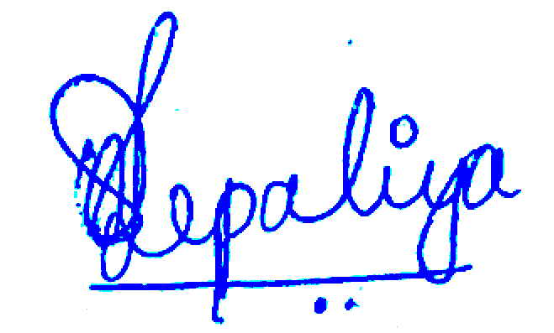

Urveesh Jepaliya

____________________________________________________________________________________________________________
Unit 1: Survey 822, Village Bhumapura, Ahmedabad – Mahemdavad Road, Dist. Kheda, Gujarat – 387130, India.
Unit 2: 75/A, Akshar Industrial Park, B/H Amba Estate, Nr. Hathijan Circle, Vatva GIDC Phase-4, Ahmedabad – 382445, India.
Mobile: +919925143048 / +918758665507 Email: info@adroitextrusion.com Website: www.adroitextrusion.com


WARRANTY PERIOD:

All Mechanical components warranty for 1 year, All Pneumatic Parts Warranty for 1 year (Dry Air Compulsory with Air Compressor. If not Dry Air, then Warranty will not Apply), Drives Warranty for 1 year (Voltage stabilizer compulsory, If not then Warranty will not Apply) All Electrical & Electronics parts like Switch, Contactor, MCB, etc. warranty for 06 months from date of commissioning against faulty material or bad workmanship and undertake to repair/replacement the defective parts within period. The defect brought to notice has to be genuine. The cost of the new materials or repairing of the defective ones will be borne by the Seller. However, the cost of transportation and destination clearance charges etc. will be borne by the buyer.
•⁠ ⁠The buyer is required to return the defective parts or equipment to seller or to the manufacturer and the cost for the same will be bear by the buyer
In case of payment terms agreed upon in the contract are not been obeyed, the warranty expires consequentially.

WARRANTY EXCLUDES FOLLOWING:

Parts made of rubber, plastic, glass. Bearings, wearing parts, fuses, heaters, lamps, contactors, MCB’s etc. The warranty does not cover damages caused by dropping, fire, floods or other natural calamity, misuse, accident or improper installation. The life span of screw and barrel depends upon abrasive material being processed and hence cannot be specified.

WARRANTY IS LIMITED to the extend of the repairs or replacement of manufacturing defects and other things or workmanship. No liability is assumed beyond such replacements.

Any condition or other matters relating to this quotation not expressly stimulated will be a matter of mutual discussion and agreement at the time of accepting the order.

It is understood that order once placed cannot be cancelled for any reason whatso ever. In case of cancellation of the order, the entire amount of the advance will be forfeited.

____________________________________________________________________________________________________________
Unit 1: Survey 822, Village Bhumapura, Ahmedabad – Mahemdavad Road, Dist. Kheda, Gujarat – 387130, India.
Unit 2: 75/A, Akshar Industrial Park, B/H Amba Estate, Nr. Hathijan Circle, Vatva GIDC Phase-4, Ahmedabad – 382445, India.
Mobile: +919925143048 / +918758665507 Email: info@adroitextrusion.com Website: www.adroitextrusion.com

